Course Name: | Web Development Laboratory (316U01L306) | Semester: | III
Date of Performance: | 12 / 8 / 2026 | DIV/ Batch No: | A1
Student Name: | Mrudul Bhagwat | Roll No: | 16010125020

Experiment No: 2
Title: Design web Portal using CSS3.

Aim of the Experiment: To apply CSS3 style sheets to an existing HTML5-based Web Portal for the given Use Case study in order to enhance layout, responsiveness, visual aesthetics, and user interaction using modern CSS3 features.

Objectives for the Experiment:
- Implement different CSS3 styling techniques
- Design responsive layouts using Flexbox and media queries
- Enhance user interaction using animations
- Maintain separation of content and presentation

COs to be achieved:
CO1: Use CSS to prepare the layout of web pages.

Books/ Journals/ Websites references:
- https://www.w3schools.com/css/
- https://developer.mozilla.org/en-US/docs/Web/CSS

Theory:
Students should write about CSS3 (citation needed for content taken (IEEE or APA7 style))

Problem statement: Demonstrate the implementation of CSS3 features to enhance the layout, responsiveness, and aesthetics of the selected HTML-based web portal for the selected Use Case in experiment 1.
Note: All tasks are compulsory to use.

Task 1: Style the Homepage Header (Inline CSS)
Requirements:
- Use inline CSS to:
  - Set background color for header
  - Change text color of title
  - Center align slogan
  - Add padding and border
- Apply inline style to:
  - <h1>, <p>, <header>
Concepts tested:
Inline CSS, color, background, padding, text-align, border.

Task 2: Internal CSS for Navigation Menu
Navigation menu should look professional and consistent across the page.
Requirements:
- Use internal CSS (<style> in <head>)
- Style navigation menu:
  - Remove bullet points
  - Display menu items horizontally
  - Add hover effect
  - Change link colors
- Use:
  - :hover, text-decoration, display: inline-block
Concepts tested:
Internal CSS, selectors, pseudo-class, styling links.

Task 3: External CSS for Whole Website Theme

For a consistent look across all pages.
Requirements:
- Create file: style.css
- Link it using <link>
- Apply:
  - Body font-family
  - Background color
  - Common heading color
  - Common footer style
Concepts tested:
External CSS, reusable styles, site-wide theming.
Deliverables : style.css linked with book.html
Task 4: Style Categories Sidebar
Categories section should look like a card.
Requirements:
- Use external or internal CSS
- Apply:
  - Border
  - Box shadow
  - Padding
  - Rounded corners
- Style list items with:
  - Spacing
  - Hover color change
Concepts tested:
Box model, border-radius, box-shadow, list styling.
Task 5: Card Layout Using CSS Box Model
To make Each item appear as a product card.
Requirements:
- Style a <div> as a book card:
  - Width, margin, padding, border
  - Center align content
- Use:
  - display: inline-block
  - Add background color and shadow
Concepts tested:
Box model, margin, padding, display property.
Deliverable : link this .css file with book.html
Task 6: Image Gallery Styling with CSS
To make Featured appropriate items/ attributes, whichever applicable in the Use Case look like a grid.
Requirements:
- Use CSS to:
  - Set same size for all images
  - Add border and hover zoom effect
  - Add spacing between images
- Use:
  - transition, transform: scale()
Concepts tested:
Image styling, hover effects, transitions.
Task 7: Table Styling for Price List
Requirements:
- Use CSS to:
  - Collapse borders
  - Add header background color
  - Zebra-striping rows
  - Center align text
- Use:
  - border-collapse, nth-child(even)
Concepts tested:
Table styling, pseudo-classes.
Deliverable table.css , link to the corresponding file.
Task 8: Style Registration Form
Requirements:
- Style:
  - Input boxes width, padding
  - Submit button color and hover effect
  - Fieldset and legend
- Use:
  - :focus, :hover
  - border-radius
Concepts tested:
Form UI styling, pseudo-classes, layout.
Deliverable : form.css
Task 9: Page Layout Using CSS (Header, Sidebar, Content, Footer)
To Create a proper website layout.
Requirements:
- Use CSS to:
  - Set sidebar to left
  - Content to right
  - Footer at bottom
- Use:
  - float or flex
  - Set widths and spacing
Concepts tested:
Layout design, positioning, float/flex.
Deliverable : layout.css

Task 10: CSS Effects & Highlighting.
To attract attention for Special events/data/section, etc..
Requirements:
- Create an “Offer” box:
  - Blinking or glowing effect
  - Different background color
  - Bigger font
- Use:
  - @keyframes animation OR hover effect
  - text-shadow, box-shadow
Concepts tested:
CSS animations, effects, visual emphasis.

Code:
GitHub Repository :https://github.com/mrudul2505/AI-based-Smart-Irrigation-Advisory-Kisan-Sathi-
Live Website : https://smartirrigation-brown.vercel.app/

Output / Screenshot:
Task 1:

Task 2:
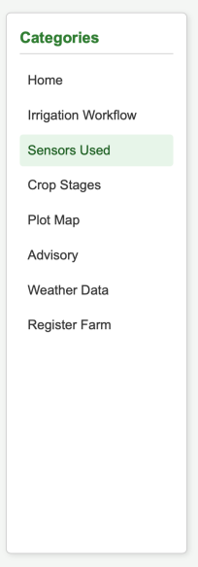

Task 3:
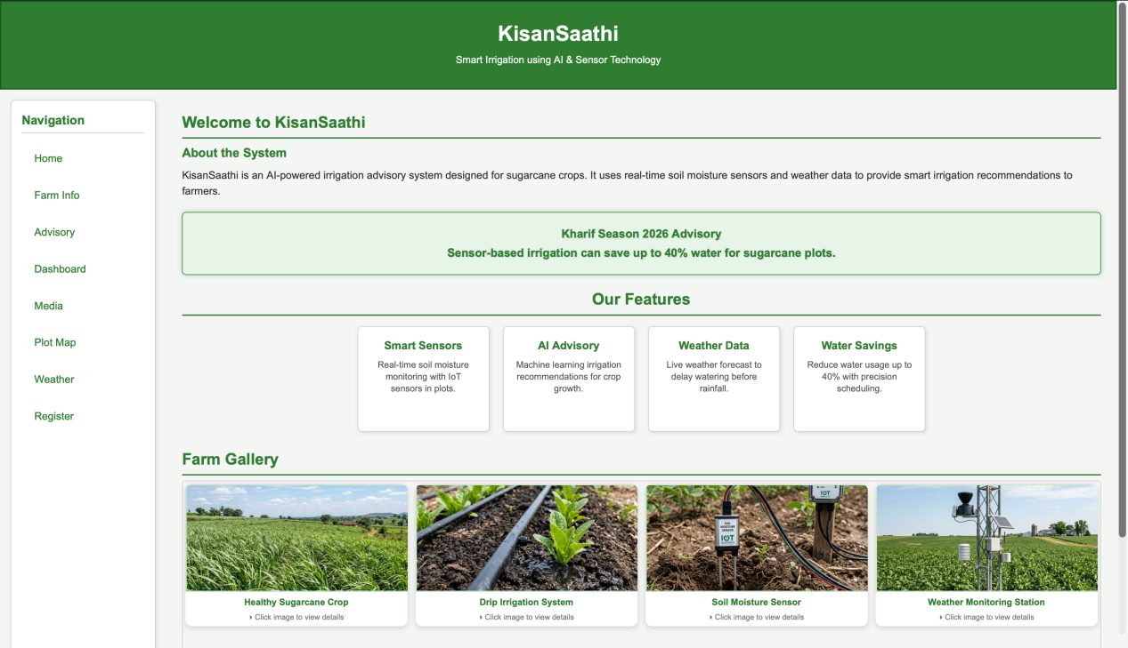
Task 4:
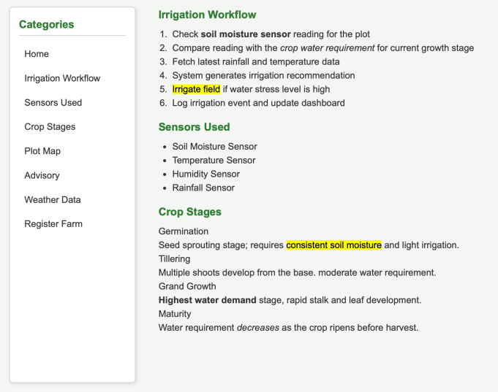
Task 5:
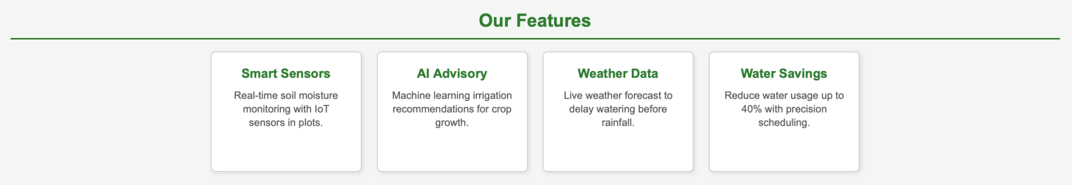
Task 6:
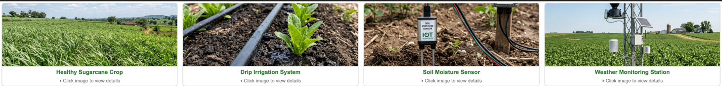
Task 7:
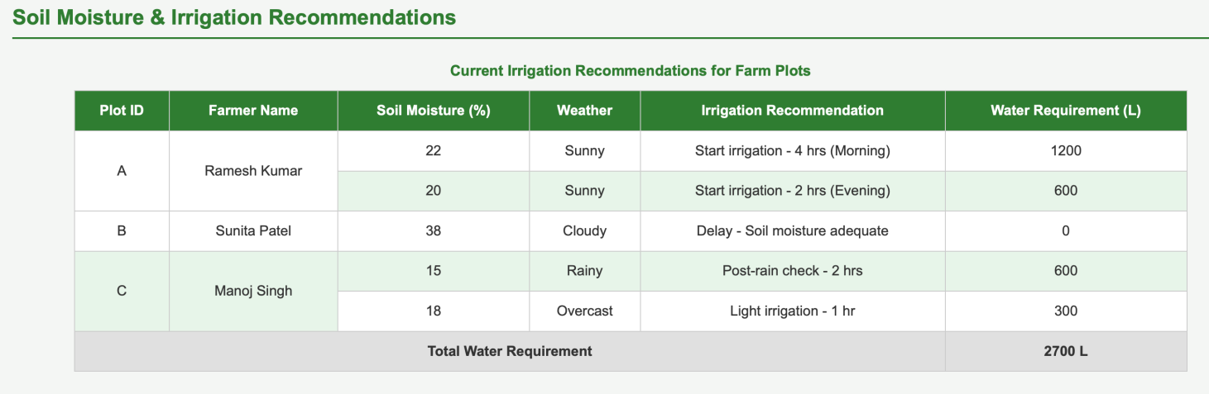

Task 8:
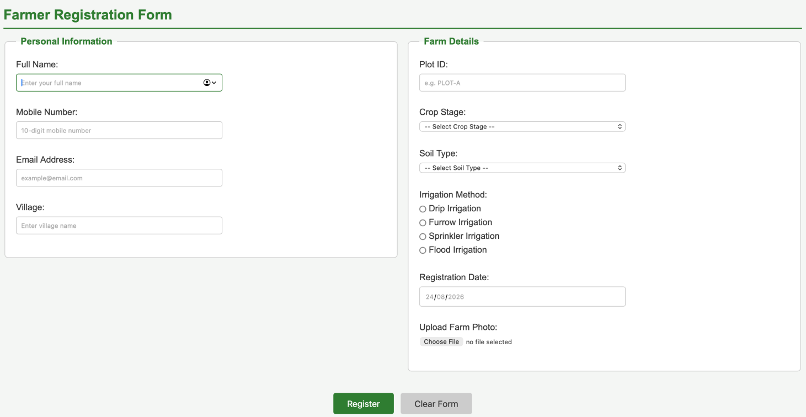
Task 9:
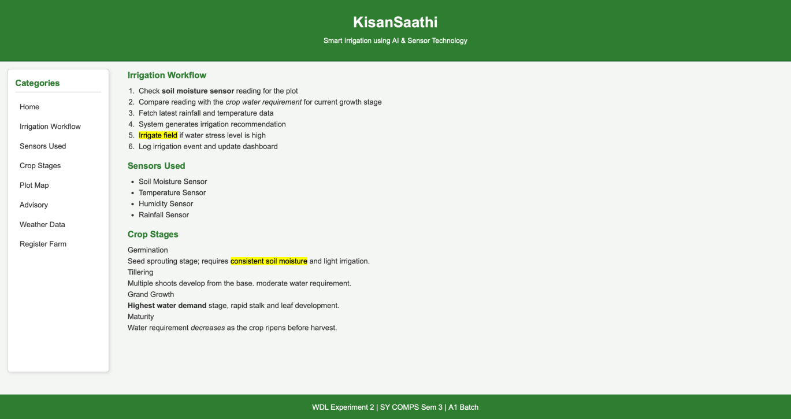
Task 10:
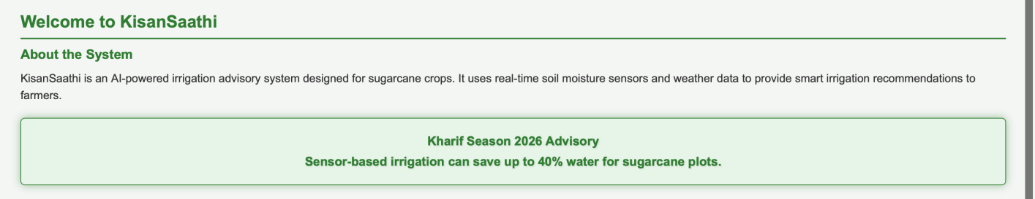

Post Lab Subjective/Objective type Questions:
- Use Bootstrap for CSS.
Ans: Bootstrap is a CSS framework that contains ready to use classes and components for the purpose of designing responsive websites in no time. Some of its built-in classes include those for layout, navigation bar, form, button, table, card, and grid.

Conclusion and Discussion:
CSS was successfully applied to improve the website’s layout, responsiveness, appearance, and user interaction using different styling techniques. The experiment demonstrated the effective use of CSS concepts such as the box model, Flexbox, pseudo-classes, animations, forms, and responsive layouts.

